Linux Servers
Classroom Assignment 3 – Services and packaging
Joni Korpihalkola
Document your commands or take screenshots. Answer questions in english or finnish.

Packages
Clean the package cache first.
Find out which repository includes the package mod_ssl. What webserver does it need? What other packages it has as dependencies? What is the version and architecture of the package?
Install mod_ssl. Are all the packages from the same repository? Why?
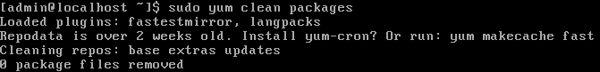
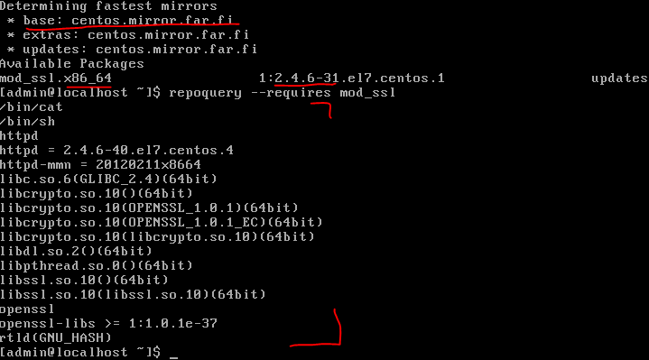
Webserver: centos.mirror.far.fi
Arkkitehtuuri: 64-bittinen
Versio: 2.4.6
Muut vaadittavat paketit listattiin repoquery –requires komennolla.
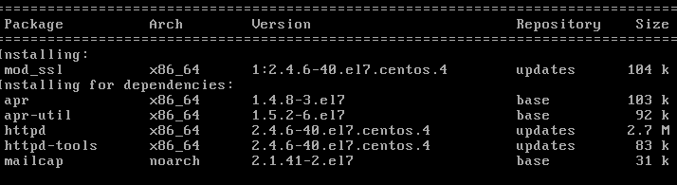
Kaikki paketit eivät tulleet samasta repositoriosta, joitakin päivitettiin updates-repositoriosta ja jotkin ladattiin kokonaan base-repositoriosta.

Provides
What package provides the command sealert (hint: yum provides sealert). What repository is it from? Install that package.
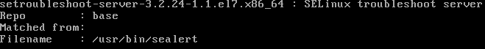 repository: base

EPEL
Install epel-release package. Does this package have a dedicated architecture? Why? Is the EPEL repository enabled by default?
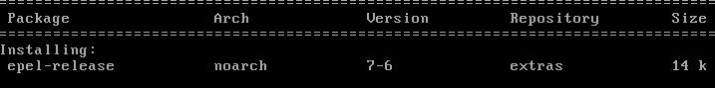
Epel-releasen arkkitehtuuri on no architecture, eli se voidaan asentaa mihinkä tahansa arkkitehtuuriin tahansa. Extras repository on enabloitu by default

Systemctl
As you installed the mod_ssl, it installed the webserver automatically. What is the service name for the web server? What is the current status of the service? (systemctl status <webservername>)
Start the webserver and enable it so it is started at every boot.
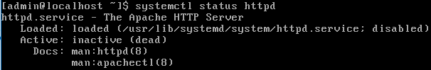
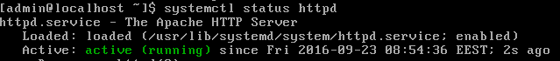

Kernel
Check your current kernel version with uname –r. Update the kernel and take note of the new kernel version. Why does the kernel version shown in uname –r not change?
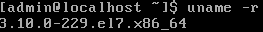
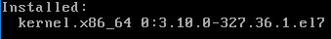
Kernelin päivityksen jälkeen kone piti käynnistää uudelleen, jotta uname näyttää uuden version.

Updates
Update the rest of the system. NEVER cancel the update when it is installing packages (Canceling when it is downloading is ok as no packages are yet installed)
Reboot and check that there are no new updates pending.
